

CENTRO UNIVERSITÁRIO INTERNACIONAL UNINTER

ESCOLA SUPERIOR POLITÉCNICA

BACHARELADO EM ENGENHARIA DE SOFTWARE

FERRAMENTAS DE DESENVOLVIMENTO WEB

ATIVIDADE PRÁTICA

Diuliano pereira venancio, RU: 3675109

margarete klamas, esp

Uberlandia-mg

2022

1. Pastas

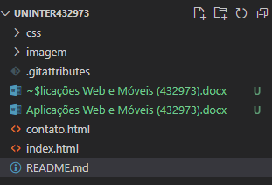

1. Arquivos - **https://github.com/diulianovenancio/Uninter432973**
   1. Index.html

<!doctype html>

<html lang="pt-br">

  <head>

    <meta charset="utf-8">

    <link rel="icon" href="imagem/favicon.png">

    <meta name="viewport" content="width=device-width, initial-scale=1">

    <title>Aplicações Web e Móveis (432973)</title>

    <link href="https://cdn.jsdelivr.net/npm/bootstrap@5.2.0/dist/css/bootstrap.min.css" rel="stylesheet" integrity="sha384-gH2yIJqKdNHPEq0n4Mqa/HGKIhSkIHeL5AyhkYV8i59U5AR6csBvApHHNl/vI1Bx" crossorigin="anonymous">

    <link rel="stylesheet" href="https://cdnjs.cloudflare.com/ajax/libs/font-awesome/6.1.2/css/all.min.css" integrity="sha512-1sCRPdkRXhBV2PBLUdRb4tMg1w2YPf37qatUFeS7zlBy7jJI8Lf4VHwWfZZfpXtYSLy85pkm9GaYVYMfw5BC1A==" crossorigin="anonymous" referrerpolicy="no-referrer" />

    <link rel="stylesheet" href="css/personalizado.css">

  </head>

  <body>

    <!-- Menu do Site -->

    <nav class="navbar navbar-expand-lg navbar-dark fixed-top bg-dark">

        <div class="container">

            <a class="navbar-brand" href="index.html"><img src="https://getbootstrap.com/docs/5.2/assets/brand/bootstrap-logo.svg" alt="" width="30" height="24"></a>

            <button class="navbar-toggler" type="button" data-toggle="collapse" data-target="#navbarsExample07" aria-controls="navbarsExample07" aria-expanded="false" aria-label="Toggle navigation">

                <span class="navbar-toggler-icon"></span>

            </button>

            <div class="collapse navbar-collapse justify-content-md-center" id="navbarsExample07">

                <ul class="navbar-nav mr-auto">

                    <li class="nav-item">

                        <a class="nav-link active" href="index.html">Inicio</a>

                    </li>

                    <li class="nav-item">

                        <a class="nav-link" href="contato.html">Contato</a>

                    </li>

                </ul>

            </div>

        </div>

    </nav>

    <!-- Banner inicial -->

    <div class="jumbotron descr-top">

        <div class="container text-center">

            <h1 class="display-4">Diuliano Pereira Venâncio</h1>

            <p class="lead">Trabalho como desenvolvedor freelancer e programador por hobby.<br/>Gosto de passar meu tempo livre com minha esposa e família, jogando vídeo games e happy hour com amigos.</p>

            <a class="btn btn-primary btn-lg" href="contato.html" role="button">Entre em Contato</a>

        </div>

    </div>

    <div class="jumbotron descr-serv">

        <div class="container text-center">

            <h2 class="display-4">Habilidades</h2>

            <p class="lead pb-4">Em constante treinamento e desenvolvimento das minhas habilidades na programação. Estou sempre buscando novos recursos de aprendizagem com novas tecnologias. Trabalho com desenvolvimento web já à alguns anos, conheci a linguagem PHP e me identifiquei muito com a linguagem.</p>

            <div class="row">

                <div class="col-lg-3">

                    <div class="rounded-circle circulo centralizar border border-info shadow" data-bs-toggle="modal" data-bs-target="#frontend">

                        <i class="fa-brands fa-css3"></i>

                    </div>

                    <h2 class="mt-4 mb-4">Front-End</h2>

                    <p>Para o visual do sistema ou site. Trabalho com HTML, CSS, Bootstrap, JavaScript</p>

                </div>

                <div class="col-lg-3">

                    <div class="rounded-circle circulo centralizar border border-info shadow" data-bs-toggle="modal" data-bs-target="#backend">

                        <i class="fa-solid fa-laptop-code"></i>

                    </div>

                    <h2 class="mt-4 mb-4">Back-End</h2>

                    <p>Desenvolvo o sistema usando PHP</p>

                </div>

                <div class="col-lg-3">

                    <div class="rounded-circle circulo centralizar border border-info shadow" data-bs-toggle="modal" data-bs-target="#bancodedados">

                        <i class="fa-solid fa-microchip"></i>

                    </div>

                    <h2 class="mt-4 mb-4">Banco de Dados</h2>

                    <p>Para guardar os dados uso o banco de dados MySQL</p>

                </div>

                <div class="col-lg-3">

                    <div class="rounded-circle circulo centralizar border border-info shadow" data-bs-toggle="modal" data-bs-target="#sistemaoperacional">

                        <i class="fa-brands fa-linux"></i>

                    </div>

                    <h2 class="mt-4 mb-4">Sistema Operacional</h2>

                    <p>Windows e Linux</p>

                </div>

            </div>

        </div>

    </div>

    <div class="jumbotron descr-det">

        <div class="container">

            <h2 class="display-4 text-center titulo">Portifolio</h2>

            <div class="row featurette">

                <div class="col-md-7 order-md-2">

                    <h2 class="featurette-heading">Donatella Vendas</h2>

                    <p class="lead">Sistema criado para gerenciar vendas.</p>

                </div>

                <div class="col-md-5 order-md-1">

                    <a href="https://donatellavendas.com.br" target="_blank"><img src="imagem/donatellavendas.png" class="bd-placeholder-img bd-placeholder-img-lg featurette-image img-fluid mx-auto" width="500" height="500" alt="Donatella Vendas"></a>

                </div>

            </div>

            <div class="row featurette">

                <div class="col-md-7 order-md-1">

                    <h2 class="featurette-heading">Sang Go Jae Doramas</h2>

                    <p class="lead">E-commerce para vendas de doramas.</p>

                </div>

                <div class="col-md-5 order-md-2">

                    <a href="https://www.sanggojaedoramas.com" target="_blank"><img src="imagem/sanggojaedoramas.png" class="bd-placeholder-img bd-placeholder-img-lg featurette-image img-fluid mx-auto" width="500" height="500" alt="Sang Go Jae Doramas"></a>

                </div>

            </div>

            <div class="row featurette">

                <div class="col-md-7 order-md-2">

                    <h2 class="featurette-heading">Delivery</h2>

                    <p class="lead">Sistema de vendas delivery</p>

                </div>

                <div class="col-md-5 order-md-1">

                    <a href="https://delivery.muitomassa.com.br" target="_blank"><img src="imagem/delivery.png" class="bd-placeholder-img bd-placeholder-img-lg featurette-image img-fluid mx-auto" width="500" height="500" alt="Delivery"></a>

                </div>

            </div>

            <div class="row featurette">

                <div class="col-md-7 order-md-1">

                    <h2 class="featurette-heading">Costa Ambiental</h2>

                    <p class="lead">Site com portifolio da empresa, onde tem acesso a uma área restrita com gestão dos projetos.</p>

                </div>

                <div class="col-md-5 order-md-2">

                    <a href="https://costaambiental.com" target="_blank"><img src="imagem/costaambiental.png" class="bd-placeholder-img bd-placeholder-img-lg featurette-image img-fluid mx-auto" width="500" height="500" alt="Sang Go Jae Doramas"></a>

                </div>

            </div>

        </div>

    </div>

    <div class="jumbotron time-line">

        <ul class="timeline-with-icons">

            <li class="timeline-item mb-5">

                <span class="timeline-icon">

                    <i class="fa-solid fa-briefcase text-primary fa-sm"></i>

                </span>

                <h5 class="fw-bold">Supervisor de TI</h5>

                <p class="text-muted mb-2 fw-bold">2015 - Atual</p>

                <p><em>Autus</em></p>

            </li>

            <li class="timeline-item mb-5">

                <span class="timeline-icon">

                    <i class="fa-solid fa-briefcase text-primary fa-sm"></i>

                </span>

                <h5 class="fw-bold">Técnico em Telecomunicação</h5>

                <p class="text-muted mb-2 fw-bold">2014 - 2015</p>

                <p><em>Eletrotel</em></p>

            </li>

            <li class="timeline-item mb-5">

                <span class="timeline-icon">

                    <i class="fa-solid fa-briefcase text-primary fa-sm"></i>

                </span>

                <h5 class="fw-bold">Analista de Sistema</h5>

                <p class="text-muted mb-2 fw-bold">2013 - 2014</p>

                <p><em>Laboratório DIU Saúde</em></p>

            </li>

            <li class="timeline-item mb-5">

                <span class="timeline-icon">

                    <i class="fa-solid fa-briefcase text-primary fa-sm"></i>

                </span>

                <h5 class="fw-bold">Auxiliar Suporte Técnico</h5>

                <p class="text-muted mb-2 fw-bold">2012 - 2013</p>

                <p><em>Hospital Santa Catarina</em></p>

            </li>

            <li class="timeline-item mb-5">

                <span class="timeline-icon">

                    <i class="fa-solid fa-briefcase text-primary fa-sm"></i>

                </span>

                <h5 class="fw-bold">Técnico de Informática</h5>

                <p class="text-muted mb-2 fw-bold">2011 - 2012</p>

                <p><em>TexStore</em></p>

            </li>

            <li class="timeline-item mb-5">

                <span class="timeline-icon">

                    <i class="fa-solid fa-briefcase text-primary fa-sm"></i>

                </span>

                <h5 class="fw-bold">Operador de Telemarketing Corporativo</h5>

                <p class="text-muted mb-2 fw-bold">2010 - 2011</p>

                <p><em>Algar Tecnologia</em></p>

            </li>

            <li class="timeline-item mb-5">

                <span class="timeline-icon">

                    <i class="fa-solid fa-briefcase text-primary fa-sm"></i>

                </span>

                <h5 class="fw-bold">Instrutor de Informática</h5>

                <p class="text-muted mb-2 fw-bold">2007 - 2010</p>

                <p><em>Pratik Cursos Profissionalizantes</em></p>

            </li>

            <li class="timeline-item mb-5">

                <span class="timeline-icon">

                    <i class="fa-solid fa-graduation-cap text-secondary fa-sm"></i>

                </span>

                <h5 class="fw-bold">Curso Profissionalizante</h5>

                <p class="text-muted mb-2 fw-bold">2005 - 2006</p>

            </li>

            <li class="timeline-item mb-5">

                <span class="timeline-icon">

                    <i class="fa-solid fa-school  text-secondary fa-sm"></i>

                </span>

                <h5 class="fw-bold">Ensino Médio</h5>

                <p class="text-muted mb-2 fw-bold">2003 - 2006</p>

            </li>

        </ul>

    </div>

    <div class="jumbotron footer-per">

        <div class="container">

            <div class="row">

                <div class="col-12 col-sm-12 col-md-4">

                    <h5>© Copyright Diuliu's</h5>

                    <ul class="list-unstyled">

                        <li>

                            <a href="index.html" class="link-footer">Inicio</a>

                        </li>

                        <li>

                            <a href="contato.html" class="link-footer">Contato</a>

                        </li>

                    </ul>

                </div>

                <div class="col-12 col-sm-12 col-md-4">

                </div>

                <div class="col-12 col-sm-12 col-md-4">

                    <h5>Redes Sociais</h5>

                    <ul class="list-unstyled">

                        <li>

                            <i class="fa-brands fa-instagram"></i> <a href="https://www.instagram.com/diulianopereira" target="_blank" class="link-footer">Instagram</a>

                        </li>

                        <li>

                            <i class="fa-brands fa-github"></i> <a href="https://github.com/diulianovenancio" target="_blank" class="link-footer">GitHub</a>

                        </li>

                        <li>

                            <i class="fa-brands fa-linkedin"></i> <a href="https://www.linkedin.com/in/diuliano-pereira-ven%C3%A2ncio-16485573/" target="_blank" class="link-footer">Linkedin</a>

                        </li>

                        <li>

                            <i class="fa-brands fa-twitter"></i> <a href="https://twitter.com/diuliano.pereira" target="_blank" class="link-footer">Twiter</a>

                        </li>

                    </ul>

                </div>

            </div>

        </div>

    </div>

<!-- === Modais === -->

<!-- Front End -->

<div class="modal fade" id="frontend" data-bs-backdrop="static" data-bs-keyboard="false" tabindex="-1" aria-labelledby="frontendLabel" aria-hidden="true">

    <div class="modal-dialog modal-dialog-centered">

        <div class="modal-content">

        <div class="modal-header">

            <h5 class="modal-title text-center" id="frontendLabel">Front-End</h5>

            <button type="button" class="btn-close" data-bs-dismiss="modal" aria-label="Close"></button>

        </div>

        <div class="modal-body">

            <i class="fa-brands fa-html5"></i> HTML5

            <div class="progress">

                <div class="progress-bar progress-bar-striped progress-bar-animated bg-success" role="progressbar" aria-label="Animated striped" aria-valuenow="100" aria-valuemin="0" aria-valuemax="100" style="width: 100%">100%</div>

            </div>

            <br/>

            <i class="fa-brands fa-css3-alt"></i> CSS

            <div class="progress">

                <div class="progress-bar progress-bar-striped progress-bar-animated bg-success" role="progressbar" aria-label="Animated striped" aria-valuenow="98" aria-valuemin="0" aria-valuemax="100" style="width: 98%">98%</div>

            </div>

            <br/>

            <i class="fa-brands fa-js"></i> JS

            <div class="progress">

                <div class="progress-bar progress-bar-striped progress-bar-animated bg-warning" role="progressbar" aria-label="Animated striped" aria-valuenow="87" aria-valuemin="0" aria-valuemax="100" style="width: 87%">87%</div>

            </div>

            <br/>

            <i class="fa-brands fa-bootstrap"></i> Bootstrap

            <div class="progress">

                <div class="progress-bar progress-bar-striped progress-bar-animated bg-success" role="progressbar" aria-label="Animated striped" aria-valuenow="92" aria-valuemin="0" aria-valuemax="100" style="width: 92%">92%</div>

            </div>

        </div>

        <div class="modal-footer">

            <button type="button" class="btn btn-secondary" data-bs-dismiss="modal">Fechar</button>

        </div>

        </div>

    </div>

</div>

<!-- Back End -->

<div class="modal fade" id="backend" data-bs-backdrop="static" data-bs-keyboard="false" tabindex="-1" aria-labelledby="backendLabel" aria-hidden="true">

    <div class="modal-dialog modal-dialog-centered">

        <div class="modal-content">

        <div class="modal-header">

            <h5 class="modal-title text-center" id="backendLabel">Back-End</h5>

            <button type="button" class="btn-close" data-bs-dismiss="modal" aria-label="Close"></button>

        </div>

        <div class="modal-body">

            <i class="fa-brands fa-php"></i> PHP

            <div class="progress">

                <div class="progress-bar progress-bar-striped progress-bar-animated bg-success" role="progressbar" aria-label="Animated striped" aria-valuenow="93" aria-valuemin="0" aria-valuemax="100" style="width: 93%">93%</div>

            </div>

            <br/>

            <i class="fa-brands fa-python"></i> Python

            <div class="progress">

                <div class="progress-bar progress-bar-striped progress-bar-animated bg-danger" role="progressbar" aria-label="Animated striped" aria-valuenow="8" aria-valuemin="0" aria-valuemax="100" style="width: 8%">8%</div>

            </div>

            <br/>

            <i class="fa-brands fa-node-js"></i> NodeJS

            <div class="progress">

                <div class="progress-bar progress-bar-striped progress-bar-animated bg-danger" role="progressbar" aria-label="Animated striped" aria-valuenow="3" aria-valuemin="0" aria-valuemax="100" style="width: 3%">3%</div>

            </div>

            <br/>

            <i class="fa-brands fa-git-alt"></i> Git

            <div class="progress">

                <div class="progress-bar progress-bar-striped progress-bar-animated bg-info" role="progressbar" aria-label="Animated striped" aria-valuenow="27" aria-valuemin="0" aria-valuemax="100" style="width: 27%">27%</div>

            </div>

        </div>

        <div class="modal-footer">

            <button type="button" class="btn btn-secondary" data-bs-dismiss="modal">Fechar</button>

        </div>

        </div>

    </div>

</div>

<!-- Banco de Dados -->

<div class="modal fade" id="bancodedados" data-bs-backdrop="static" data-bs-keyboard="false" tabindex="-1" aria-labelledby="bancodedadosLabel" aria-hidden="true">

    <div class="modal-dialog modal-dialog-centered">

        <div class="modal-content">

        <div class="modal-header">

            <h5 class="modal-title text-center" id="bancodedadosLabel">Banco de Dados</h5>

            <button type="button" class="btn-close" data-bs-dismiss="modal" aria-label="Close"></button>

        </div>

        <div class="modal-body">

            <i class="fa-solid fa-database"></i> Mysql

            <div class="progress">

                <div class="progress-bar progress-bar-striped progress-bar-animated bg-warning" role="progressbar" aria-label="Animated striped" aria-valuenow="81" aria-valuemin="0" aria-valuemax="100" style="width: 81%">81%</div>

            </div>

        </div>

        <div class="modal-footer">

            <button type="button" class="btn btn-secondary" data-bs-dismiss="modal">Fechar</button>

        </div>

        </div>

    </div>

</div>

<!-- Sistema Operacional -->

<div class="modal fade" id="sistemaoperacional" data-bs-backdrop="static" data-bs-keyboard="false" tabindex="-1" aria-labelledby="sistemaoperacionalLabel" aria-hidden="true">

    <div class="modal-dialog modal-dialog-centered">

        <div class="modal-content">

        <div class="modal-header">

            <h5 class="modal-title text-center" id="sistemaoperacionalLabel">Sistema Operacional</h5>

            <button type="button" class="btn-close" data-bs-dismiss="modal" aria-label="Close"></button>

        </div>

        <div class="modal-body">

            <i class="fa-brands fa-windows"></i> Windows Desktop

            <div class="progress">

                <div class="progress-bar progress-bar-striped progress-bar-animated bg-success" role="progressbar" aria-label="Animated striped" aria-valuenow="93" aria-valuemin="0" aria-valuemax="100" style="width: 93%">93%</div>

            </div>

            <br/>

            <i class="fa-brands fa-ubuntu"></i> Linux Desktop

            <div class="progress">

                <div class="progress-bar progress-bar-striped progress-bar-animated bg-info" role="progressbar" aria-label="Animated striped" aria-valuenow="8" aria-valuemin="0" aria-valuemax="100" style="width: 57%">57%</div>

            </div>

            <br/>

            <i class="fa-solid fa-display-code"></i> Windows Server

            <div class="progress">

                <div class="progress-bar progress-bar-striped progress-bar-animated bg-warning" role="progressbar" aria-label="Animated striped" aria-valuenow="73" aria-valuemin="0" aria-valuemax="100" style="width: 73%">73%</div>

            </div>

            <br/>

            <i class="fa-brands fa-linux"></i> Linux Server

            <div class="progress">

                <div class="progress-bar progress-bar-striped progress-bar-animated bg-warning" role="progressbar" aria-label="Animated striped" aria-valuenow="68" aria-valuemin="0" aria-valuemax="100" style="width: 68%">68%</div>

            </div>

        </div>

        <div class="modal-footer">

            <button type="button" class="btn btn-secondary" data-bs-dismiss="modal">Fechar</button>

        </div>

        </div>

    </div>

</div>

    <script src="https://cdn.jsdelivr.net/npm/bootstrap@5.2.0/dist/js/bootstrap.bundle.min.js" integrity="sha384-A3rJD856KowSb7dwlZdYEkO39Gagi7vIsF0jrRAoQmDKKtQBHUuLZ9AsSv4jD4Xa" crossorigin="anonymous"></script>

  </body>

</html>

* 1. Contato.html

<!doctype html>

<html lang="pt-br">

  <head>

    <meta charset="utf-8">

    <link rel="icon" href="imagem/favicon.png">

    <meta name="viewport" content="width=device-width, initial-scale=1">

    <title>Aplicações Web e Móveis (432973)</title>

    <link href="https://cdn.jsdelivr.net/npm/bootstrap@5.2.0/dist/css/bootstrap.min.css" rel="stylesheet" integrity="sha384-gH2yIJqKdNHPEq0n4Mqa/HGKIhSkIHeL5AyhkYV8i59U5AR6csBvApHHNl/vI1Bx" crossorigin="anonymous">

    <link rel="stylesheet" href="https://cdnjs.cloudflare.com/ajax/libs/font-awesome/6.1.2/css/all.min.css" integrity="sha512-1sCRPdkRXhBV2PBLUdRb4tMg1w2YPf37qatUFeS7zlBy7jJI8Lf4VHwWfZZfpXtYSLy85pkm9GaYVYMfw5BC1A==" crossorigin="anonymous" referrerpolicy="no-referrer" />

    <link rel="stylesheet" href="css/personalizado.css">

  </head>

  <body>

    <!-- Menu do Site -->

    <nav class="navbar navbar-expand-lg navbar-dark fixed-top bg-dark">

        <div class="container">

            <a class="navbar-brand" href="index.html"><img src="https://getbootstrap.com/docs/5.2/assets/brand/bootstrap-logo.svg" alt="" width="30" height="24"></a>

            <button class="navbar-toggler" type="button" data-toggle="collapse" data-target="#navbarsExample07" aria-controls="navbarsExample07" aria-expanded="false" aria-label="Toggle navigation">

                <span class="navbar-toggler-icon"></span>

            </button>

            <div class="collapse navbar-collapse justify-content-md-center" id="navbarsExample07">

                <ul class="navbar-nav mr-auto">

                    <li class="nav-item">

                        <a class="nav-link" href="index.html">Inicio</a>

                    </li>

                    <li class="nav-item">

                        <a class="nav-link active" href="contato.html">Contato</a>

                    </li>

                </ul>

            </div>

        </div>

    </nav>

    <div class="jumbotron head-contato">

        <div class="container">

            <h1 class="text-center">Contato</h1>

        </div>

    </div>

    <div class="jumbotron contato">

        <div class="container">

            <div class="row featurette">

                <div class="col-md-6 mb-4">

                    <form>

                        <div class="form-group">

                            <label for="name">Nome</label>

                            <input name="name" type="text" class="form-control" id="name" placeholder="Nome completo" required>

                        </div>

                        <div class="form-group">

                            <label for="email">E-mail</label>

                            <input name="email" type="email" class="form-control" id="email" placeholder="Seu melhor e-mail" required>

                        </div>

                        <div class="form-group">

                            <label for="subject">Assunto</label>

                            <input name="subject" type="text" class="form-control" id="subject" placeholder="Assunto da mensagem" required>

                        </div>

                        <div class="form-group">

                            <label for="content">Mensagem</label>

                            <textarea name="content" class="form-control" id="content" rows="3" placeholder="Conteúdo da mensagem" required></textarea>

                        </div>

                        <button type="submit" class="btn btn-primary">Enviar</button>

                    </form>

                </div>

                <div class="col-md-6">

                    <h3 class="text-center">Entre em contato e vamos trabalhar juntos!</h3>

                    <hr>

                    <address>

                        <i class="bi bi-geo-alt"></i>

                        <h4>Cidade: <small class="text-muted">Uberlândia, MG</small></h4>

                    </address>

                    <iframe src="https://www.google.com/maps/embed?pb=!1m18!1m12!1m3!1d120774.86487335252!2d-48.33360580089021!3d-18.921896225410386!2m3!1f0!2f0!3f0!3m2!1i1024!2i768!4f13.1!3m3!1m2!1s0x94a4450c10bbbaef%3A0xae370c93616d5c9c!2zVWJlcmzDom5kaWEsIE1H!5e0!3m2!1spt-BR!2sbr!4v1660822481701!5m2!1spt-BR!2sbr" frameborder="0" style="border:0; width: 100%; height: 250px;" allowfullscreen></iframe>

                </div>

            </div>

        </div>

    </div>

    <div class="jumbotron footer-per">

        <div class="container">

            <div class="row">

                <div class="col-12 col-sm-12 col-md-4">

                    <h5>© Copyright Diuliu's</h5>

                    <ul class="list-unstyled">

                        <li>

                            <a href="index.html" class="link-footer">Inicio</a>

                        </li>

                        <li>

                            <a href="contato.html" class="link-footer">Contato</a>

                        </li>

                    </ul>

                </div>

                <div class="col-12 col-sm-12 col-md-4">

                </div>

                <div class="col-12 col-sm-12 col-md-4">

                    <h5>Redes Sociais</h5>

                    <ul class="list-unstyled">

                        <li>

                            <i class="fa-brands fa-instagram"></i> <a href="https://www.instagram.com/diulianopereira" target="_blank" class="link-footer">Instagram</a>

                        </li>

                        <li>

                            <i class="fa-brands fa-github"></i> <a href="https://github.com/diulianovenancio" target="_blank" class="link-footer">GitHub</a>

                        </li>

                        <li>

                            <i class="fa-brands fa-linkedin"></i> <a href="https://www.linkedin.com/in/diuliano-pereira-ven%C3%A2ncio-16485573/" target="_blank" class="link-footer">Linkedin</a>

                        </li>

                        <li>

                            <i class="fa-brands fa-twitter"></i> <a href="https://twitter.com/diuliano.pereira" target="_blank" class="link-footer">Twiter</a>

                        </li>

                    </ul>

                </div>

            </div>

        </div>

    </div>

    <script src="https://cdn.jsdelivr.net/npm/bootstrap@5.2.0/dist/js/bootstrap.bundle.min.js" integrity="sha384-A3rJD856KowSb7dwlZdYEkO39Gagi7vIsF0jrRAoQmDKKtQBHUuLZ9AsSv4jD4Xa" crossorigin="anonymous"></script>

  </body>

</html>

* 1. Personalizado.css

/* cover: Uma palavra-chave que é o inverso de contain. Ajusta a imagem o mais largamente possível e mantém sua proporção (a imagem não fica esticada). A imagem "cobre" o container inteiro, tanto em altura como em largura. Quando a imagem e o container têm diferentes dimensões,a imagem ultrapassa os limites do container em qualquer direção, para continuar mantendo a proporção. Fonte: https://developer.mozilla.org/pt-BR/docs/Web/CSS/background-size */

/* Seletor para personalizar o topo da página home */

.descr-top{

    background-image: url('../imagem/topo.jpg');

    background-repeat: no-repeat;

    background-position: center;

    background-size: cover;

    padding-top: 120px;

    padding-bottom: 120px;

    color: #fff;

    margin-bottom: 0rem !important;

    border-radius: .0rem;

}

/* Seletor para personalizar a área de serviços da página home */

.descr-serv{

    background-color: #fff;

    padding-top: 80px;

    padding-bottom: 80px;

    border-radius: 0px;

    margin-bottom: 0rem !important;

}

.circulo{

    width: 130px;

    height: 120px;

    font-size: 45px;

    padding-top: 24px;

}

.circulo:hover{

    background-color: #0095eb;

    color: #fff;

}

.centralizar{

    margin: 0 auto !important;

    float: none !important;

}

/* Seletor para personalizar a área da ação da página home */

.descr-action{

    background-image: url("../imagem/chamada_acao.jpg");

    background-repeat: no-repeat;

    background-position: center;

    background-size: cover;

    padding-top: 80px;

    padding-bottom: 80px;

    color: #fff;

    margin-bottom: 0rem !important;

    border-radius: 0rem;

}

/* Seletor para personalizar a área detalhes do serviço na página home */

.descr-det{

    padding-top: 80px;

    padding-bottom: 80px;

    background-color: #f0f0f0;

    margin-bottom: 0rem !important;

    border-radius: 0rem;

}

.titulo{

    padding-bottom: 60px;

}

/* Seletor para personalizar o rodapé da página */

.footer-per{

    background-color: #090622;

    padding-top: 30px;

    padding-bottom: 30px;

    color: #fff;

    margin-bottom: 0rem !important;

    border-radius: 0rem;

}

.footer-per ul li a.link-footer{

    color: #fff !important;

    text-decoration: none;

}

.footer-per ul li a.link-footer:hover{

    color: #00F !important;

    text-decoration: none;

}

/* Seletor para personalizar o titulo da página contato*/

.head-contato{

    padding-top: 60px;

    padding-bottom: 0px;

    background-color: #fff;

    margin-bottom: 0rem !important;

    border-radius: 0rem;

}

.contato{

    padding-top: 60px;

    padding-bottom: 60px;

    background-color: #fff;

    margin-bottom: 0rem !important;

    border-radius: 0rem;

}

/* time line */

.time-line{

    margin: 50px;

}

.timeline-with-icons {

    border-left: 1px solid hsl(0, 0%, 90%);

    position: relative;

    list-style: none;

}

.timeline-with-icons .timeline-item {

    position: relative;

}

.timeline-with-icons .timeline-item:after {

    position: absolute;

    display: block;

    top: 0;

}

.timeline-with-icons .timeline-icon {

    position: absolute;

    left: -48px;

    background-color: hsl(217, 88.2%, 90%);

    color: hsl(217, 88.8%, 35.1%);

    border-radius: 50%;

    height: 31px;

    width: 31px;

    display: flex;

    align-items: center;

    justify-content: center;

}

1. São duas telas

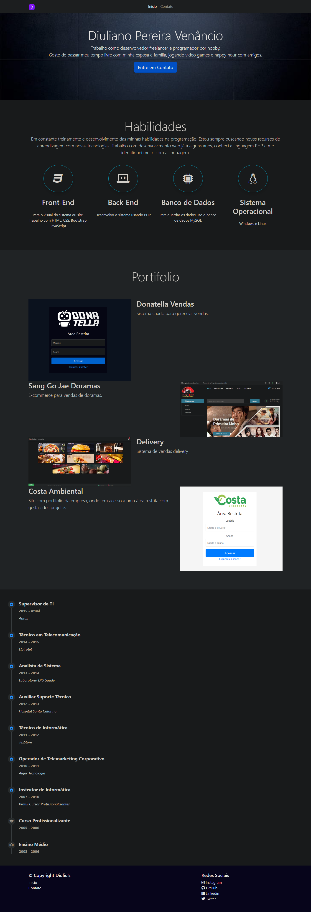

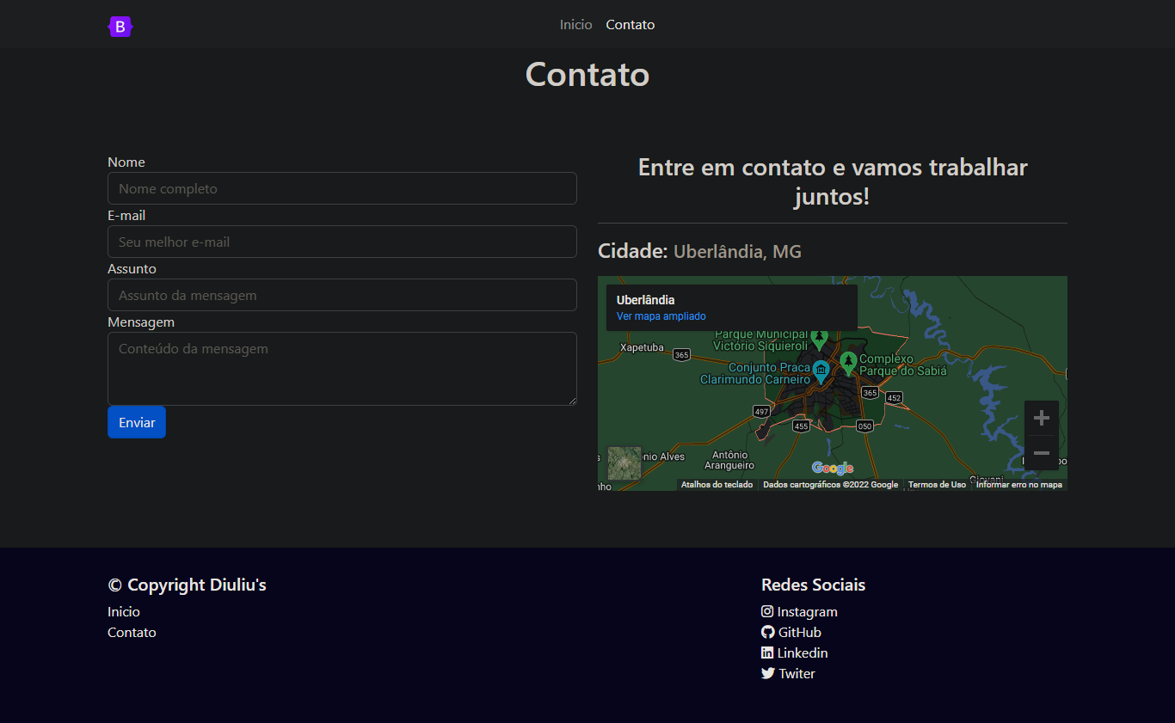

1. https://diulianovenancio.github.io/Uninter432973/